**INTRODUCTION TO CSS GRID**

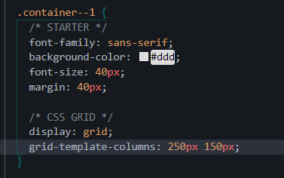

The grid-template-columns: defines how many columns we need along with how much width for each

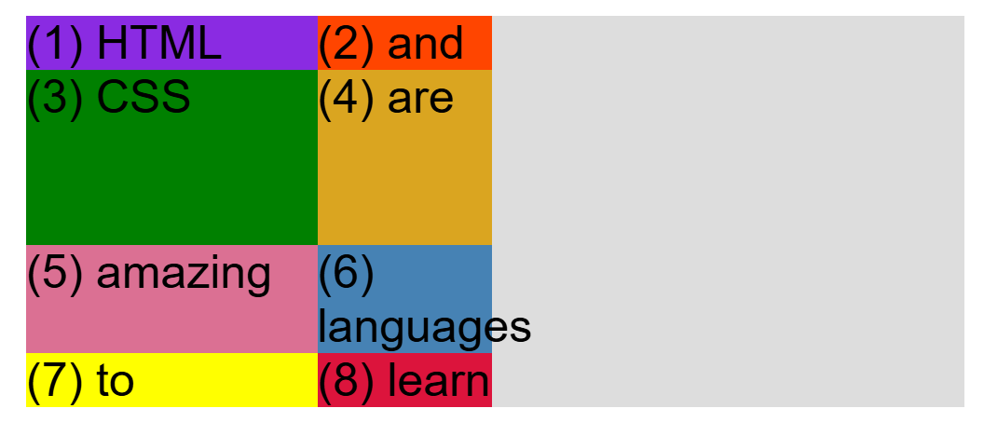

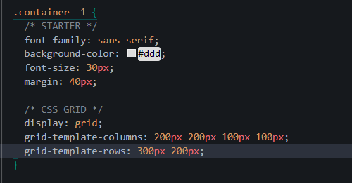

Here grid-template-rows defines how many rows we want with how much height

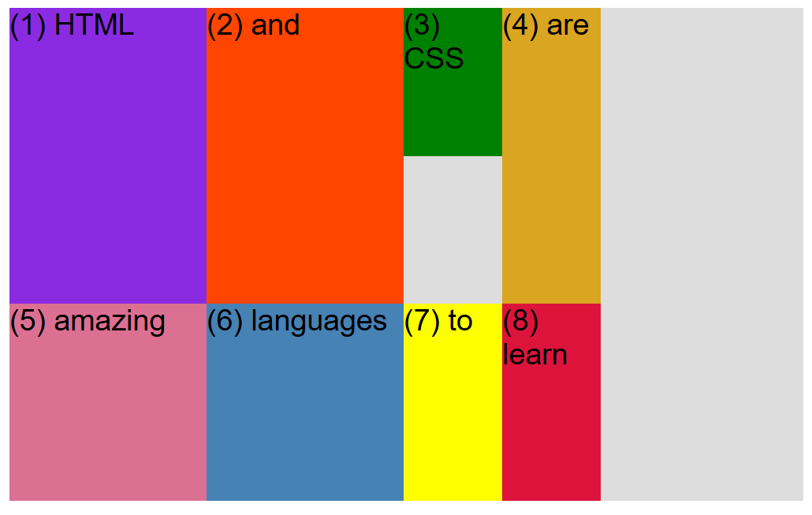

Css one is very small because its height has been defined above of 150px.

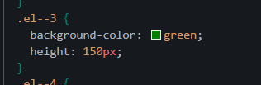

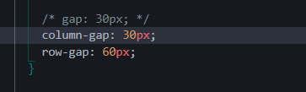

This helps define the gap between the columns and rows

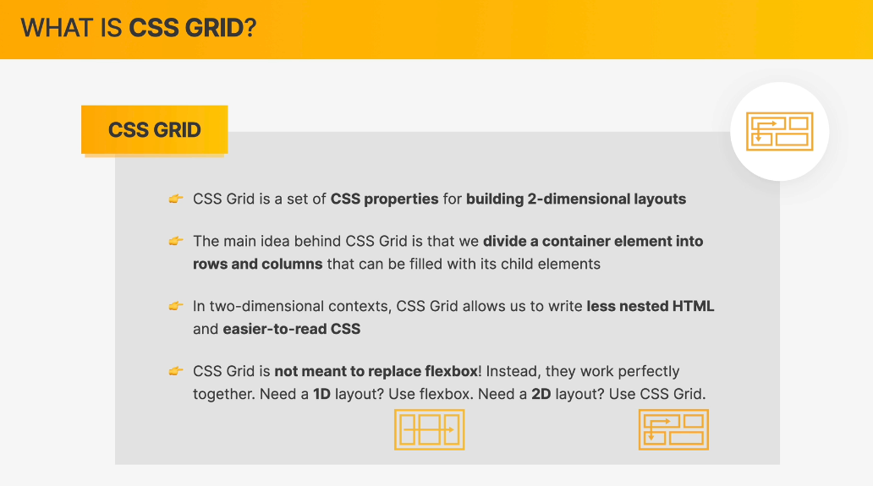

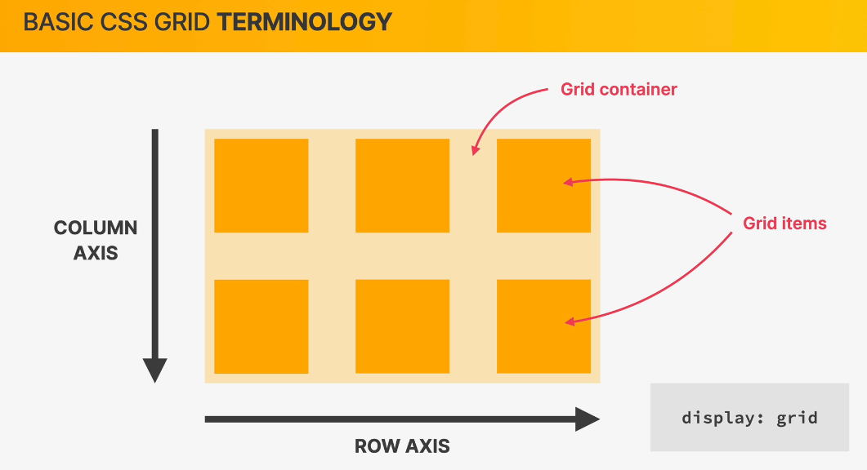

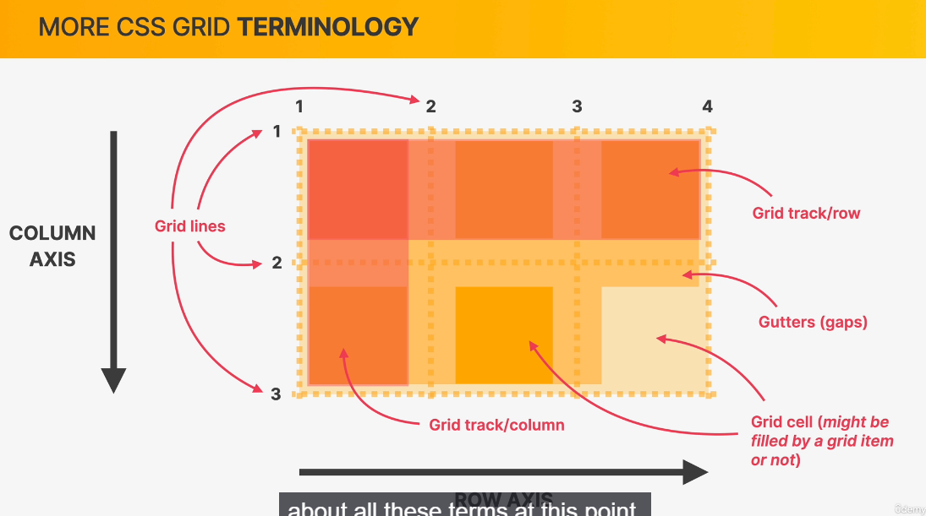

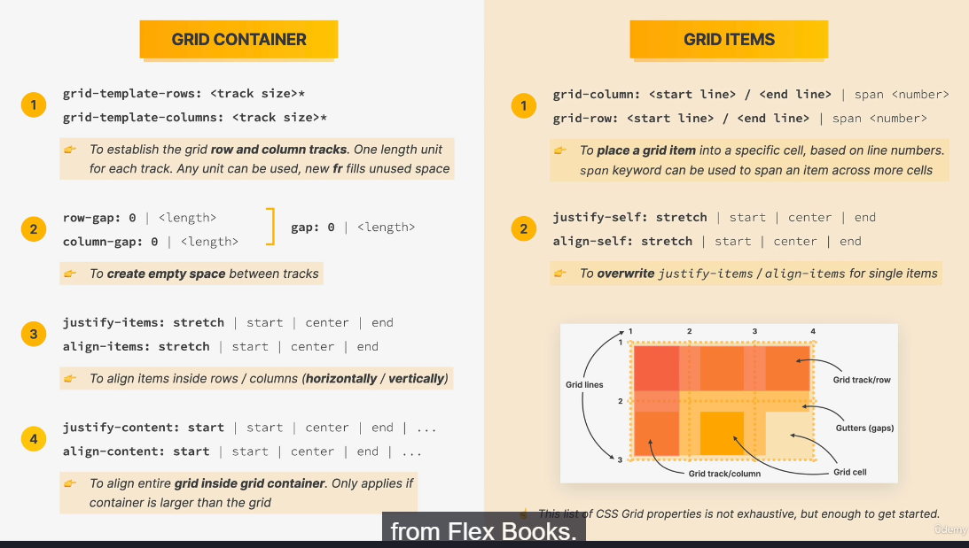

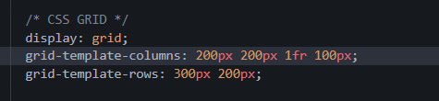

1fr means 1 fraction it adjusts the size flexibly. And increases or decreases as the size of the window changes flexibly.

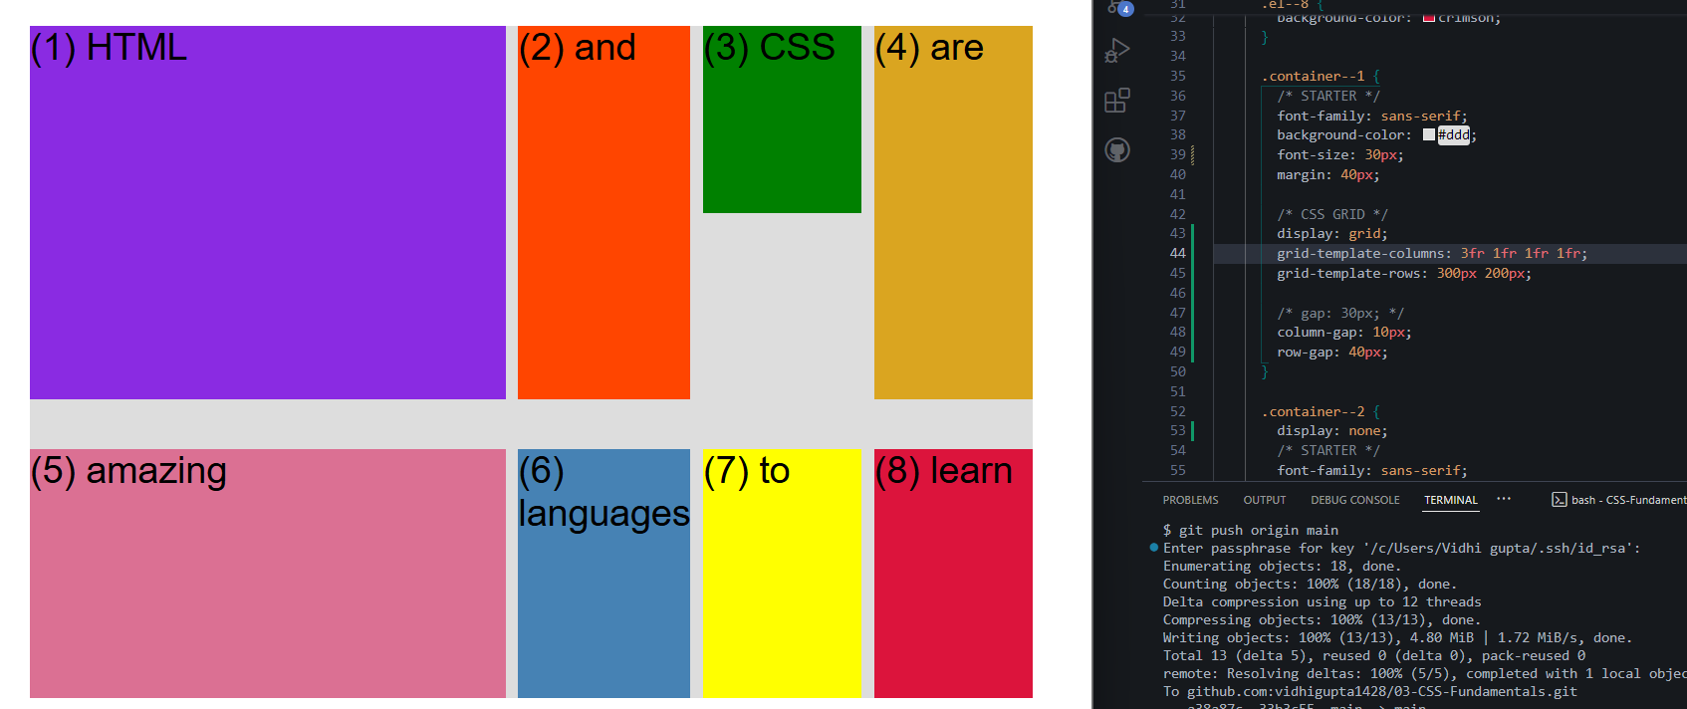

3fr means 3 times the empty space it covers.



Auto means it will only take the space required nothing more than that



Equivalent to typing 1fr 4 times

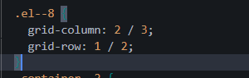

Move this item in column 2 to 3 and row 1 to 2 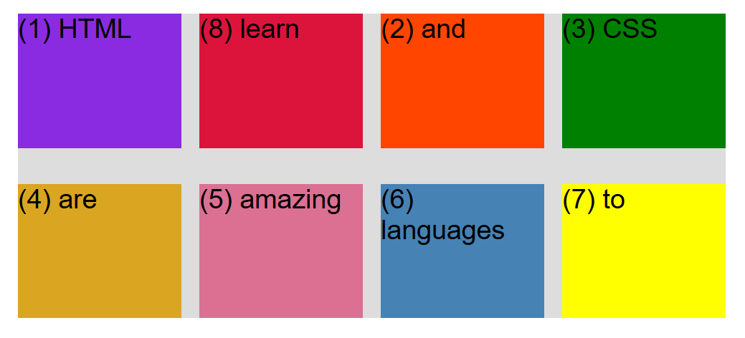

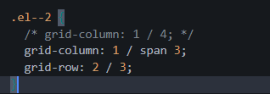

Start from 1 and span to 3 cells

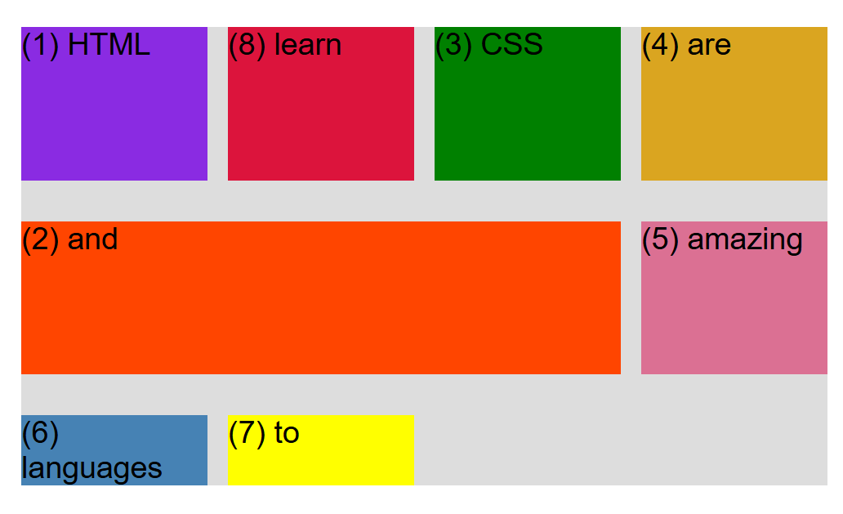

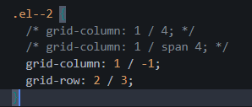

Go from 1 end to the last end when we don’t know the number of grids

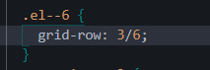

A new row was inserted

